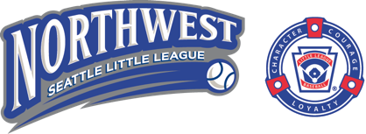

Attention 2020 NW Seattle Little League Coaches!
Northwest Seattle Little League ("NWSLL") is partnering with both Mark Linden from Baseball Positive and Mark Zender from Mariners Grand Slam Camps to train NWSLL coaches for the upcoming 2020 season!

Scheduled Sessions

Mark Linden (Baseball Positive)

Date | Time | Skill Level | Location
Feb 11 (Tue) | 6:00-8:30 PM | Kid-Pitch | @ Fairview Church – 844 NE 78th Street
Mar 3 (Tue) | 6:00-8:30 PM | Coach-Pitch | @ Fairview Church
Mar 22 (Sun) | 9:00-11:00 AM | Tee-Ball | @ East Green Lake Park (NE Diamond) (just SE of the Community Center)

Mark Zender (Mariners Grand Slam Camps)

Date | Time | Organization | Location
Feb 29 (Sat) | 12:30-3:30 PM | LL District 8 | @ Wallingford Boys & Girls Club

Alternate Sessions

Mark Linden (Baseball Positive)

Mark Linden conducts coach training sessions for other leagues at various locations around Puget Sound, including south Snohomish, Kirkland, Bellevue, Sammamish, and south Seattle. If you are unable to attend a scheduled session above, you can attend at another date and location. Please inquire with Tracy Lemke at ts_lemke@hotmail.com for more details.

Mark Zender (Mariners Grand Slam Camps)

Mark Zender conducts a condensed version of his training as part of the Seattle Mariners Coach Clinic with Scott Servais at T-Mobile Park on Saturday, January 25th from 10:00 AM to noon. Attendance is limited. Register here: https://www.mlb.com/mariners/community/on-base/coaches-clinics/seattle.

Cost: Free to NWSLL coaches!

